**Chapter Executive Committee ~ Meeting Minutes ~ July 14, 2024, ~ 11:30pm Soldiers & Sailors or Virtual**

1. Call to Order
   1. Tiffany Ripperda, Fabricio Rodrigues, Ally Kerr, Amanda Jandt, Amanda Shoop, Darcy McGuigan, Jessica Duval, Sarah Wellner, Cassandra Ryckman, Shenal Premarathna
2. Review, addition to, adoption of agenda
   1. Amanda J motions to approve, Fabricio seconds. Motion carried.
3. Approval of Prior Meeting Minutes (Katie L.)
   1. Darcy motions to approve, Fabricio seconds. Motion carried.
4. Treasurer’s Report (Cassandra) – balance $24,932.49
   1. Revenues: None
   2. Expenses: None
   3. Amanda S accepts as presented.
5. Old Business
6. Directors Reports
   1. ACE Reporting (Darcy)
      1. Pulse Checks are due November 1, February 1, and May 1 (Final report)
      2. Submitted CEC board members and track on ACE reporting
   2. Accountability (Sarah)
      1. Let Sarah know if you are interested in helping her create the CCR report.
   3. Bylaws and Procedures (Katie)
      1. Made changes last year, with potential no changes to this year
   4. Professional Certification (Tiffany)
   5. Communications (Nicole)
      1. Keep Nicole updated with information that could be used to posted on Facebook
   6. Community Service (Allysen)
   7. Early Careers (Shenal)
      1. Darcy will send out an email to all FO to invite interns to join AGA!
   8. Education (Brian)
   9. Membership (Fabricio)
   10. Programs & Technical (Jessica)
7. New Business:
   1. Review 2025-2026 Board Members and Positions
   2. Selection of 2025-2026 Webinars
      1. Suggest no social hour, but a chance to win something for attending virtually or in person. This might grow any type of number?
      2. Below are the 8webinar with topics and date that were picked during our meeting.

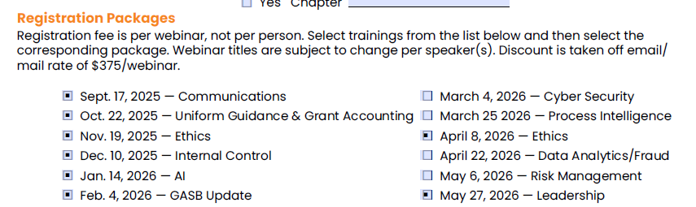

* + 1. Amanda S will reach out to Keith asking if BFM is ok with partnering with AGA to host these webinars.
    2. 4 -5 webinars in person based on topics and locations. Social hour to go with in person
    3. No gift card for attending virtual or in-person.
  1. 2025 – 2026 Chapter Affiliation Requirements
     1. Went through the ACE template as a group.
     2. Chapter audit – in the past had Matthew Fickbohm but would we want someone else to perform this task?
  2. 2025 – 2026 Key Performance Indicators
     1. Went through the ACE template as a group.
  3. 2025 – 2026 SD Chapter Plan
     1. Due September 1st. Extra 100 Points if submitted by August 1st.
  4. 2025 – 2026 Monthly Meetings
     1. Virtual, in-person, or both? Both
     2. 1st Wednesday of the 1st full week of the month? Keep and meet at 12:10 to 12:50
        1. Amanda S will set up the meeting for this year
  5. 2025 – 2026 National Events:
     1. National Leadership Training - February 18-19, 2026, Washington D.C.
     2. **Professional Development Training – July 28-29, 2025 – virtual**
     3. Internal Control & Fraud Prevention Training – September 24-25, in Washington D.C.
     4. Technology & Transformation Summit – Date: TBD but in Washington D.C.
        1. Are there any scholarships available with these national events? Amanda S will look into this
  6. 2025 – 2026 SD Chapter Events:
     1. Lunch & Learns
        1. Q1: July to September
        2. Q2: October to December
        3. Q3: January to March
           1. In March have a CGFM L&L
        4. Q4: April to June
        5. Try to find an Excel training through a L&L for this year.

1. 2026 PDC (April 15th & 16th, 2026):
   1. Venue - Drifters
   2. Speakers:
   3. Swag:$5,000 budget
      1. [7 in 1 traditional game set](https://www.4imprint.com/product/9320?gfeed=1&mkid=1pla9320&ef_id=Cj0KCQjwxdXBBhDEARIsAAUkP6hZ96W8-w5KZoARAcawXGe2jPgmEKlIj5mFsWOfLxrFyNWZd82uSh8aAgxrEALw_wcB:G:s&s_kwcid=AL!4167!3!623795073258!!!g!801253911521!!17765394368!141229280069&gad_source=1&gad_campaignid=17765394368&gbraid=0AAAAAC4jycE0lhNsokBAfvaIfEk6AExH5&gclid=Cj0KCQjwxdXBBhDEARIsAAUkP6hZ96W8-w5KZoARAcawXGe2jPgmEKlIj5mFsWOfLxrFyNWZd82uSh8aAgxrEALw_wcB)
      2. [Koozie® Backpack Cooler Chair 152518 : 4imprint.com](https://www.4imprint.com/product/152518/Koozie-Backpack-Cooler-Chair)
   4. Raffle Items:
   5. By September meeting, start bringing topics, speakers, and swag items. In the emails that Katie sends out, keep promoting topics, speakers, etc throughout our emails. Goal is to have 1 person bring a speaker/topic to the meeting.
      1. Tiffany will reach out to Kayla about seating arrangements to accommodate our attendees.
2. Other Items of Note:
   1. AJ will follow up with Mekell and Haylee regarding the SD AGA Scholarship and the requirements
3. Adjourn to next meeting, August 6th.
   1. Fabricio motions to adjourn. Amanda J seconds. Motion carried.

Respectfully submitted,

Amanda Jandt